

Thailand's Largest Seaside Running Festival by "Central Pattaya" Returns on 1 November 2025

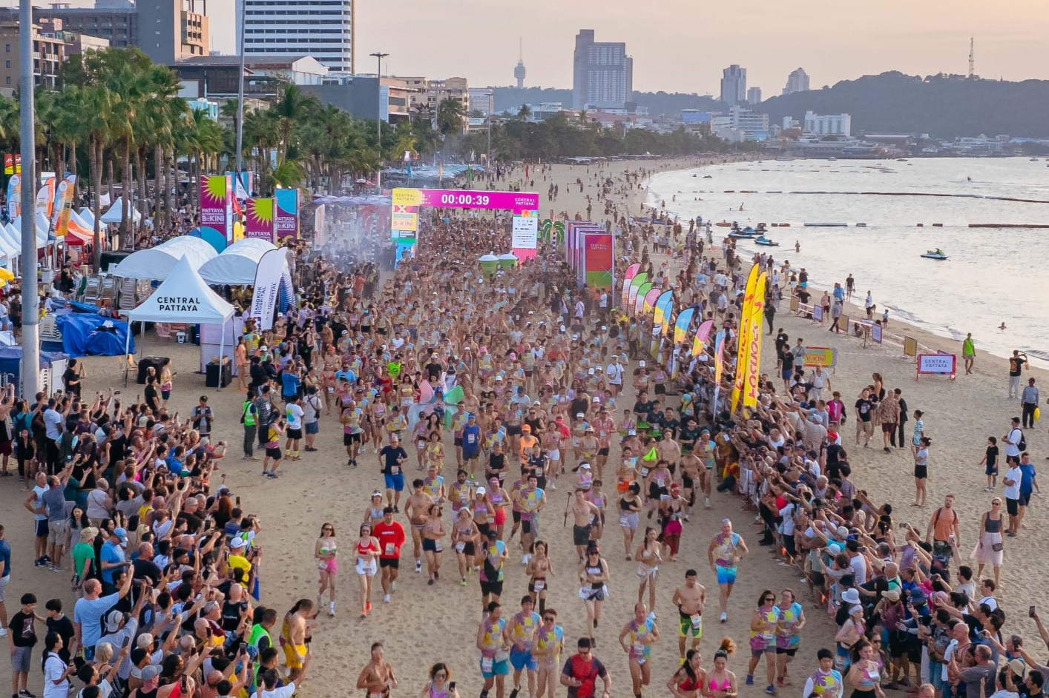

‘CENTRAL PATTAYA’, Asia’s largest natural beachfront shopping complex, invites runners from around the world to Thailand’s hottest seaside running event! The ‘PATTAYA INTERNATIONAL BIKINI BEACH RACE 2025’—the largest event of its kind in the country—returns for its 9th consecutive year under the concept Sea Sparkle Run: The Coral and Pearl Edition. The race will take place on Saturday, November 1, 2025, at Pattaya Beach, in front of Central Pattaya.
Last year, the event attracted over 5,000 runners from around the world, making it one of Thailand’s most popular seaside running festivals. Participants can enjoy a vibrant race atmosphere with live music, beach activities, and special themed experiences while taking part in a scenic beachfront run.
Registration is now open until October 29, 2025, with a fee of US$32 (1,030 baht). Secure your spot here: https://worldsmarathons.com/marathon/pattaya-bikini-run
Don’t miss the chance to be part of Thailand’s iconic seaside running celebration—run, sparkle, and make memories at the Pattaya International Bikini Beach Race 2025!

For more information, please contact: Public Relations Department, Central Pattana
Mobile: +6633003999, E-mail: prom.cpb@centralpattana.co.th

